**My Web App Deployment**

I started off by creating a task list (CRUD) application using Python and help from generative AI. The application allows users to create tasks, read them and then delete them once completed. I wanted to keep the web app basic as the main focus of this project is to get hands-on with Azure App Service Plans.  
  
- I started off by creating a resource group, I decided to keep all resources in one resource group to ensure easy clean up once the project is complete

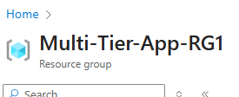

I then created an App Service Plan to host the web application; I selected the free tier to start with and will upgrade the service plan as the business needs change.



I then created the web application, linked it to the service plan and uploaded the files. I decided to manually upload the files using a zip file. I did this so I could quickly test the app. I am glad I took this approach as I got an error when I browsed to the application - Internal Server Error 500

I went through the logs, using log stream and found the following error:



I edited the app.py file to ensure the task table was created before queries are run, I then re-deployed the app.py file and the application started working.

